OceanBestPractices System: a global resource to facilitate harmonizing practices in ocean observation, data and information

Peter Pissierssens, UNESCO-IOC/IODE (Belgium), p.pissierssens@unesco.org
Cristian Muñoz, SOCIB (Spain), cmunoz@socib.es
Johannes Karstensen, GEOMAR (Germany), jkarstensen@geomar.de
Jay Pearlman, IEEE (USA), jay.pearlman@ieee.org
Pauline Simpson, UNESCO-IOC/IODE - CCMI, (Cayman Islands), psimpson@reefresearch.org
Mark Bushnell, NOAA-IOOS (USA), mark.bushnell@noaa.gov
Pier Luigi Buttigieg, AWI, (Germany), pbuttigi@mpi-bremen.de
Juliet Hermes, SAEON (South Africa), juliet@saeon.ac.za
Emma Heslop, UNESCO-IOC/GOOS (France), e.heslop@unesco.org
Frank Muller-Karger, Univ South Florida, (USA), carib@usf.edu
Francoise Pearlman, IEEE (USA), francoise.pearlman@ieee.org

Introduction
There is an ever-present need for the identification and dissemination of best practices in the multidisciplinary field of ocean observation and data management. However, the complexity of these domains and the diversity of its stakeholders make discovering relevant best practices (BP) a challenge. Addressing this challenge requires not only the creation of a repository enabling efficient discovery and access of documented best practices, but also expanding means of community engagement, including peer review and training. The AtlantOS Project (through its Best Practices Working Group), the ODIP Project, Frontiers in Marine Science and the IODE of the IOC of UNESCO and others are collaborating on the development of an enhanced Ocean Best Practices System, based upon expanding the already existing UNESCO-IOC/IODE OceanBestPractices Repository www.OceanBestPractices.net and using new means to foster OBP use by a broader ocean community. This paper presents the progress of the collaborative efforts in developing the System.

The Ocean Best Practices System
As noted above, an Ocean Best Practices System (the “OBP-S”) has been designed expressly to address the challenges of multidisciplinary research needed to answer the global challenges such as climate change and others (Pearlman et al., 2017). This solution (see Figure 1) covers the entire range of ocean observations including data management and user support and draws on the developing fields of natural language processing and ocean vocabularies (see companion paper on the OBP repository). But more than a technology implementation is needed for effective community engagement. Thus, the OBP-S will provide mechanisms for community dialogues and to facilitate publishing BPs. One aspect of this effort is the recently created Research Topic in Frontiers of Marine Science (https://www.frontiersin.org/research-topics/7173/best-practices-in-ocean-observing), which will become a place of commentary and dialog. Peer review of best practice documents is a means of promoting community adoption and providing increased visibility of methodologies. It also has significant benefits for those in universities and elsewhere that use number and quality of publications as a metric for advancement. Working together with Frontiers, the Research Topic offers this as the media to describe and disseminate robust and high-quality methodologies and interoperability, linked and referenced to the OBP repository documents as appropriate.

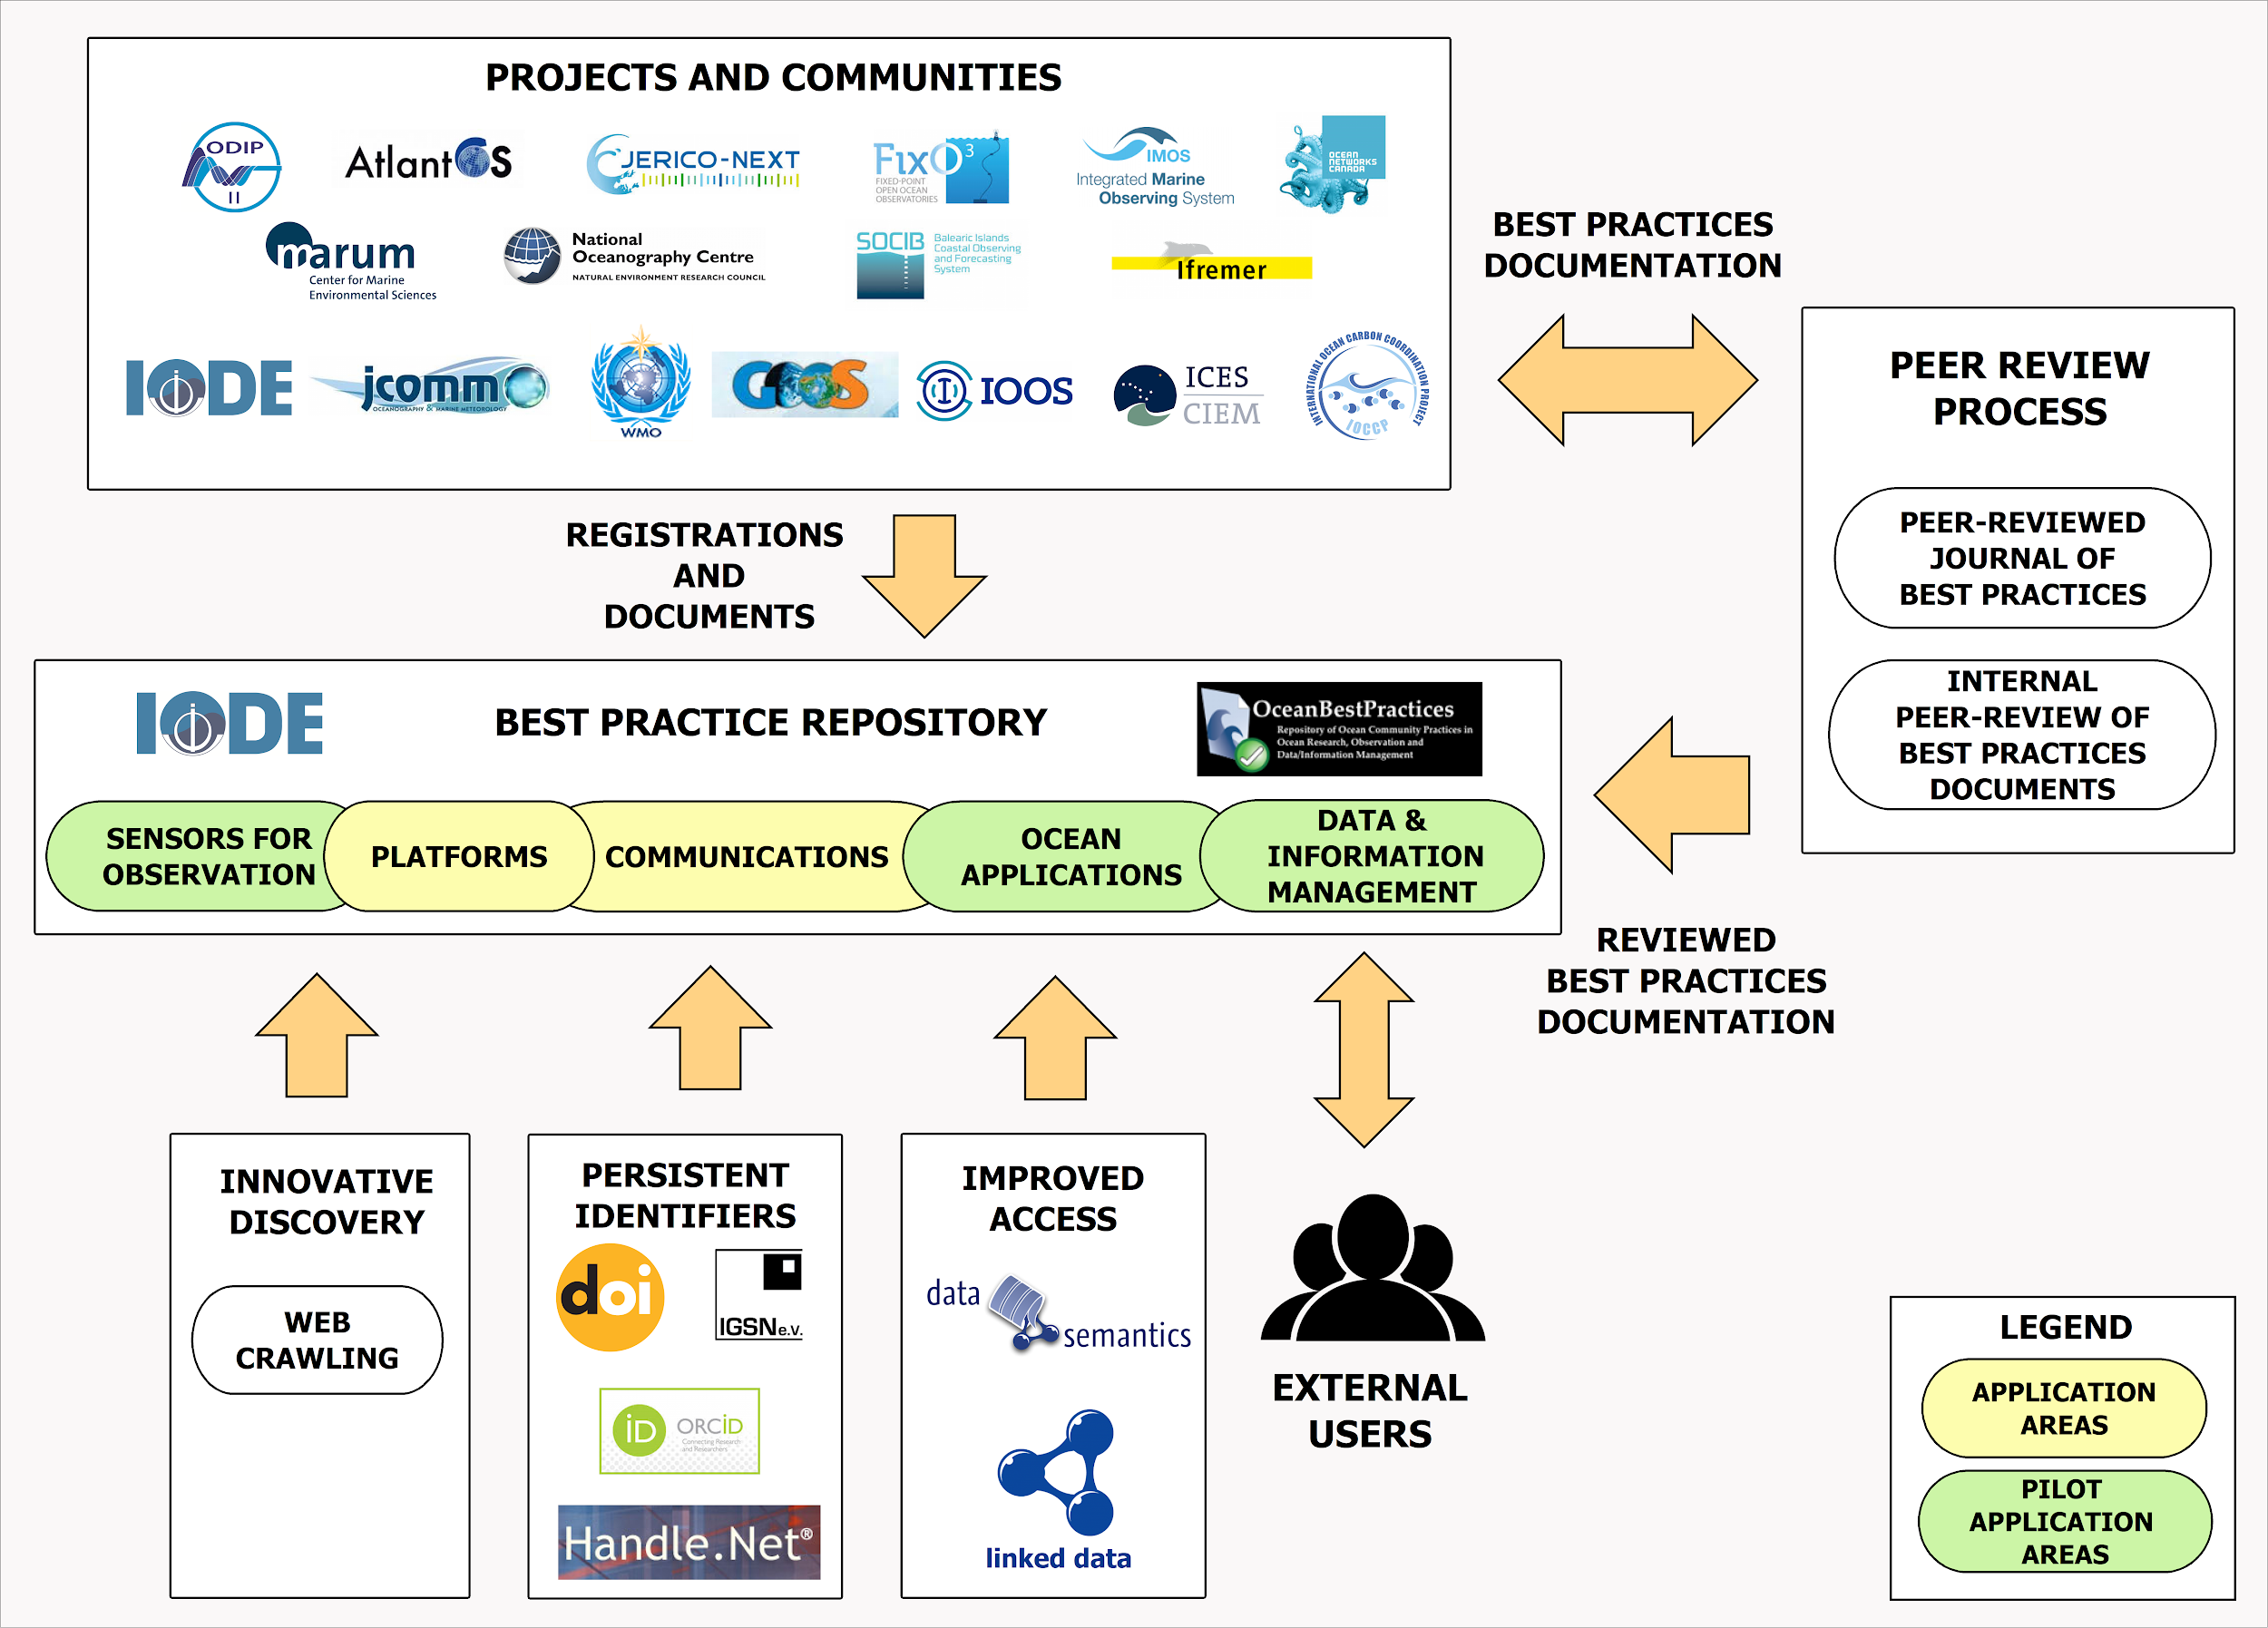
Figure 1:OBP-R end-to-end process model
As the System depends on the quality of documents provided by its stakeholders, the project will pay substantial attention to community building. Thus, OBP-S includes (1) open access from central repository, (2) multiple document locations are possible, (3) the BP developer retains control of the content, and (4) journal articles that are methods papers describing implementation and use of corresponding entries of full document in OBP-Repository. These are important, but they do not stand alone for community building. Training and capacity building are also an essential elements for BP adoption. For OBP-S, this will be done working closely with established organizations such as IODE Ocean Teacher, POGO and the SCOR Committee on Capacity Building as well as other activities such as the summer schools run by IMBER, SOLAS, GEOTRACES, etc. One of the main established platforms for providing training is the Ocean Teacher Global Academy (OTGA). OTGA aims at building equitable capacity related to ocean data and information management (as well as other IOC related disciplines) in all IOC Member States. This will ensure training and access to best practices from a global perspective and also get feedback as to the appropriateness of particular documented methodologies in the OBP-R. To further this direction, access to web based tools including information via mobile devices will be available. An advantage of this approach is that people have these as tools when they get back from training and can continue using the information and experience of the training.
Reference
Pearlman J., Buttigieg P.L., Simpson P., Muñoz Mas C., Heslop E., and Hermes J. 2017. Accessing Existing and Emerging Best Practices for Ocean Observation - a new approach for end-to-end management of Best Practices. IEEE/MTS OCEANS’17 Proceedings – Anchorage, 2017, pp 1-7.

